**PROJECT REPORT**

On

**Web Development**

PROJECT: TOURNEY

**Under the supervision of:**

Mr. Rajesh Bansal

Bangalore Computer Education

Ajit Road, Bathinda-151001

Submitted to

**YADAVINDRA DEPARTMENT OF ENGINEERING**

In partial fulfillment of the requirement for the award of

the degree of

**B. TECH**

in

**COMPUTER SCIENCE & ENGINEERING**

**Submitted By Submitted To**

Akashdeep Singh (22201103) Dr. Meenakshi Bansal

Resham Singh (22201113) Incharge T & P



**DEPARTMENT OF COMPUETER SCIENCE AND ENGINEERING**

**YADAVINDRA DEPARTMENT OF ENGINEERING**

Talwandi Sabo, Bathinda, Punjab (INDIA)

(PUNJABI UNIVERSITY PATIALA, GURU KASHI CAMPUS)

# CERTIFICATE

# 

# PREFACE

This project report is submitted as part of the B. Tech curriculum in Computer Science and Engineering, completed during the 4th semester under the esteemed guidance of Mr. Rajesh Bansal (Bangalore Computer Education). The project, titled "Tourney," is an innovative web platform designed using full-stack development technologies. It serves as an intuitive solution, enabling users to find and participate in tournaments by selecting a city and game while offering dedicated dashboards for players and organizers to manage their events efficiently.

**ACKNOWLEDGEMENT**

It is a pleasure to express our gratitude to various individuals who directly or indirectly contributed to the development of this work and influenced our thinking, behavior, and actions during the course of this study.

We express our sincere gratitude to Dr. Simpel Jindal, our esteemed Head of Department, for providing us with the opportunity to carry out the six-week training at Bangalore Computer Education.

We extend our heartfelt thanks to Mr. Rajesh Bansal and the faculty at Bangalore Computer Education for their invaluable guidance, unwavering supervision, and essential insights into the project. Their support played a pivotal role in successfully completing this project.

Lastly, we would like to thank the almighty and our parents for their moral support, as well as our friends with whom we shared our day-to-day experiences. Their suggestions and encouragement greatly enhanced the quality of our work.

**RESHAM SINGH**

**AKASHDEEP SINGH**

# CANDIDATE’S DECLARATION

We, Akashdeep Singh: Roll No. 22201103 and Resham Singh: Roll No. 22201113, B.Tech (Semester-IV) students of the Yadavindra Department of Engineering, Punjabi University Guru Kashi Campus, Talwandi Sabo, hereby declare that the Training Report entitled **“Tourney”** is our original work, and the data provided in the study is authentic to the best of our knowledge. This report has not been submitted to any other institute for the award of any other degree.

AKASHDEEP SINGH

(22201103)

RESHAM SINGH

(22201113)

**Table of Contents**

1. INTRODUCTION TO THE PROJECT 8
   1. OBJECTIVE OF PROJECT 8
   2. FEATURES OF THE PROJECT 9
   3. MODULES OF THE PROJECT 10
2. TOOLS AND TECHNOLOGIES USED IN THE PROJECT 12
   1. HTML – Hyper Text Markup language 12
   2. CSS 12
   3. BOOTSTRAP 12
   4. JAVASCRIPT 12
   5. NODEJS 12
   6. EXPRESSJS 13
   7. ANGULARJS 13
   8. NPM (NODE PACKAGE MANAGER) 13
   9. NODEMAILER 14
   10. CLOUDINARY MEDIA MANAGEMENT 14
   11. MYSQL 14
   12. AIVEN 14
   13. IDE (VISUAL STUDIO CODE) 14
   14. PLATFORM (WINDOWS 11) 15
3. PROJECT IMPLEMENTATION 16
   1. HOME PAGE 16
   2. ORGANIZER DASHBOARD 19
   3. ORGANIZER PROFILE 19
   4. PUBLISH TOURNAMENT 20
   5. PLAYER DASHBORAD 21
   6. PLAYER PROFILE 21
   7. SEARCH TOURNAMENT 22
4. RESULTS 24
5. FUTURE SCOPE 25
6. CONCLUSION 27

**1. INTRODUCTION TO THE PROJECT**

The project “**Tourney**” focuses on creating a comprehensive platform for discovering and managing tournaments near any location. It serves as a unified platform for players and organizations, enabling seamless searching, interaction, registration, and management of tournaments. By incorporating features such as user sign-up, login, dashboards, and advanced search filters, the platform enhances user convenience and improves the accessibility of tournaments for various sports and locations.

**1.1 OBJECTIVE OF THE PROJECT**

The main objective of this project is to simplify the process of finding and managing tournaments by providing a centralized digital platform. It caters to both players seeking to participate in tournaments and organizations looking to promote and manage their events. The key objectives include:

* **Streamlined User Management**: Provide an easy-to-use system for user registration, authentication, and dashboard management tailored for players and organizations.
* **Tournament Discovery**: Enable users to find tournaments by selecting cities and games, making the search process efficient and location-specific.
* **Enhanced User Interaction**: Faster collaboration between players and organizers by offering features such as event participation and management tools.
* **Digital Accessibility**: Transition the traditional tournament management process into a fully digital model, ensuring ease of use and reduced manual intervention.
* **Robust Security**: Ensure user data and tournament details are secure through authentication and access control mechanisms.

By achieving these objectives, Tourney enhances the tournament organizing and discovering process, streamlining collaboration opportunities and contributing to the growth of both players and organizers.

**1.2 FEATURES OF THE PROJECT**

* **User Registration and Login**:
  + Players and organizations can register, log in, and access personalized dashboards.
  + Secure login and session management ensure data protection.
* **Player Dashboard**:
  + View upcoming tournaments based on preferences.
  + Register and track participation in events.
* **Organization Dashboard**:
  + Create, update, and manage tournaments with detailed event information.
  + Monitor player registrations and event metrics.
* **Tournament Search**:
  + Search tournaments using city and game filters.
  + Display results dynamically with detailed tournament descriptions.
* **Notifications**:
  + Notify users about new tournaments, updates, and registrations.
* **Admin Panel**:
  + Manage users, tournaments, and overall platform activities.
  + View analytics and generate reports on user engagement.
* **Responsive Design**:
  + Optimized for different devices, ensuring accessibility across platforms.

**1.3 MODULES OF THE PROJECT**

1. **User Management Module**:
   * Handles user registration, login, and authentication.
   * Differentiates between players and organizations using role-based access control.
2. **Organization Dashboard Module**:
   * Organizations can publish tournaments.
   * Organizations can create and manage tournaments.
3. **Player Dashboard Module**:
   * Player can register himself.
   * Player can browse tournaments and register.
4. **Tournament Search Module**:
   * Allows users to filter tournaments by city and game.
   * Displays a dynamic list of tournaments with relevant details.
5. **Event Registration and Management Module**:
   * Players can register for tournaments with a single click.
   * Organizations can track registrations and manage event logistics.
6. **Security and Authentication Module**:
   * Implements secure login and access control.
   * Ensures sensitive data is protected from unauthorized access.
7. **Database Management Module**:
   * Maintains user data, tournament details, and registration records.
   * Ensures data integrity and security.

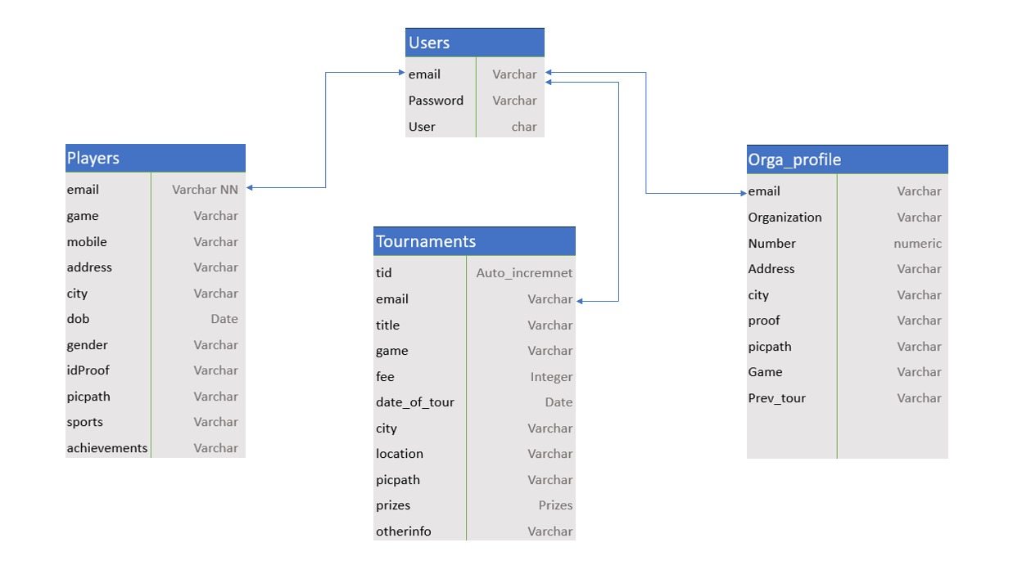

By integrating these features and modules, the platform aims to deliver an efficient and user-friendly solution for tournament discovery and management. Let me know if you'd like detailed database schemas or flow diagrams for this project!

1. **TOOLS AND TECHNOLOGIES USED**
   1. **HTML – Hyper Text Markup language**

HTML is a standardised system for tagging text files that creates the structure for just about every page that we find and use on the web. HTML stands for Hypertext Markup Language. A hypertext is a sort of meta text that is used to reference other pieces of text. The Markup Language element of HTML means that it provides a series of markings that instruct a web browser on what it should do with those pieces of text.

* 1. **CSS**

CSS is a style sheet language used for describing the presentation of a document written in HTML. It includes selectors to target HTML elements and declarations to define styles. CSS3 introduces advanced features like transitions, animations, and media queries for responsive design.

* 1. **BOOTSTRAP**

Bootstrap is a popular, open-source CSS framework that simplifies web development by providing pre-designed components and responsive grid systems. It enables developers to quickly create modern, mobile-first websites with a consistent look and feel. Bootstrap includes customizable UI elements like navigation bars, buttons, forms, and modals, which enhance the user experience. It also supports responsive design, allowing websites to adapt to various screen sizes seamlessly. With built-in JavaScript plugins for interactivity and a large community, Bootstrap is widely used for efficient and scalable web development.

* 1. **JAVASCRIPT**

JavaScript is a high-level, interpreted programming language that adds interactivity to web pages. It can manipulate the DOM (Document Object Model), handle user events, make asynchronous requests (AJAX), and create dynamic content. Popular libraries and frameworks like React and Angular are built on JavaScript.

* 1. **NODEJS**

Node.js is a powerful, open-source, server-side JavaScript runtime environment built on Chrome's V8 engine. It enables developers to build scalable, high-performance applications by using JavaScript to handle server-side logic. Node.js excels at handling asynchronous operations and is ideal for building real-time, data-intensive applications such as APIs, chat applications, and streaming services. Its non-blocking, event-driven architecture ensures efficiency and scalability, making it widely used for backend development.

* 1. **EXPRESSJS**

Express.js is a minimal and flexible web application framework for Node.js that simplifies the development of server-side applications. It provides a robust set of features for building web and mobile applications, including routing, middleware integration, and HTTP request handling. Express.js allows developers to create APIs and web services quickly with clean, modular code. Its lightweight and unopinionated nature makes it ideal for creating both simple and complex server-side applications while integrating seamlessly with databases and front-end technologies.

* 1. **ANGULARJS**

AngularJS is a JavaScript-based front-end framework developed by Google for building dynamic, single-page web applications (SPAs). It extends HTML with additional attributes and binds data to the UI using two-way data binding, which synchronizes the model and view automatically. AngularJS is known for its modular structure, dependency injection, and support for reusable components, making it easier to develop complex and maintainable applications. Its features, such as directives, templates, and built-in services, simplify client-side logic, allowing developers to build rich, interactive user interfaces efficiently.

* 1. **NPM (Node Package Manager)**

HTML is a standardised system for tagging text files that creates the structure for just about every page that we find and use on the web. HTML stands for Hypertext Markup Language. A hypertext is a sort of meta text that is used to reference other pieces of text. The Markup Language element of HTML means that it provides a series of markings that instruct a web browser on what it should do with those pieces of text.

* 1. **NODEMIALER**

Nodemailer is a popular Node.js library used for sending emails easily. It simplifies the process of integrating email functionality into applications, supporting various transport methods such as SMTP, Gmail, and others. Nodemailer allows developers to send rich HTML emails with attachments, manage multiple email accounts, and handle bounced emails effectively, making it a reliable choice for applications requiring email communication.

* 1. **CLOUDINARY MEDIA MANAGEMENT**

Cloudinary is a cloud-based media management platform that offers comprehensive solutions for image and video upload, storage, transformation, and delivery. It provides features such as automatic optimization, responsive image delivery, and extensive APIs for seamless integration into web and mobile applications. Cloudinary enhances performance and user experience by managing media assets efficiently and securely.

* 1. **MYSQL**

MySQL is an open-source relational database management system (RDBMS) widely used for storing and managing data. It utilizes a structured query language (SQL) for querying and manipulating data, making it easy to integrate with various applications. MySQL supports features such as data security, transaction management, and scalability, making it a popular choice for web applications and data-driven projects.

* 1. **AIVEN**

Aiven is a cloud-based data platform that provides managed services for various open-source technologies, including databases, messaging systems, and data pipelines. It enables developers to easily deploy, manage, and scale applications with minimal operational overhead. Aiven supports several data services such as PostgreSQL, MySQL, Apache Kafka, and Redis, offering a seamless experience for building data-driven applications in the cloud.

* 1. **IDE (VISUAL STUDIO CODE)**

Visual Studio Code (VS Code) is a powerful and lightweight integrated development environment (IDE) designed for code editing and debugging. It supports multiple programming languages and offers a rich ecosystem of extensions, making it highly customizable. VS Code features intelligent code completion, integrated Git support, debugging tools, and a user-

friendly interface, making it a popular choice among developers for both web and software development.

* 1. **PLATFORM (WINDOWS 11)**

Windows 11 is the latest version of Microsoft's operating system, designed for personal computers, laptops, and tablets. It offers a modern user interface, enhanced performance, and improved security features. Windows 11 supports a wide range of applications, including development tools and frameworks, making it an ideal platform for developers. It also includes features like virtual desktops, Snap layouts, and Microsoft Store enhancements for a more efficient user experience.

**3. PROJECT IPLEMENTATION**

**3.1 HOMEPAGE**



*Figure 3.1 HEADER*

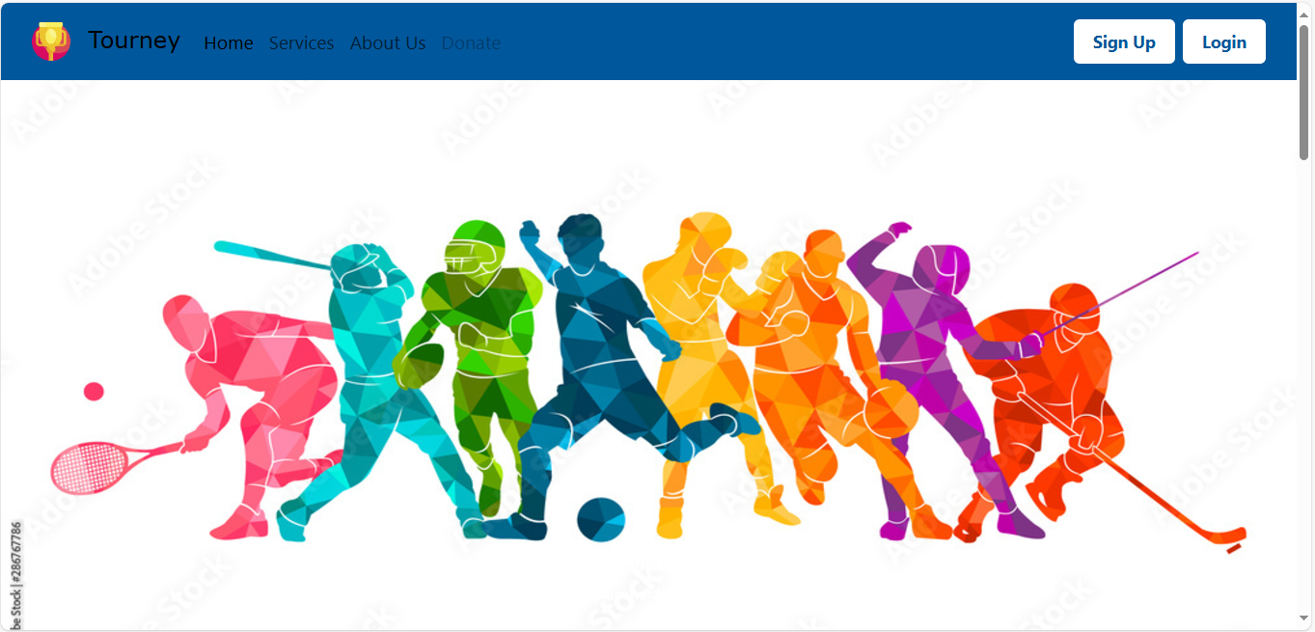

*Figure 3.2 HOEMPAGE*

*Figure 3.3 F*

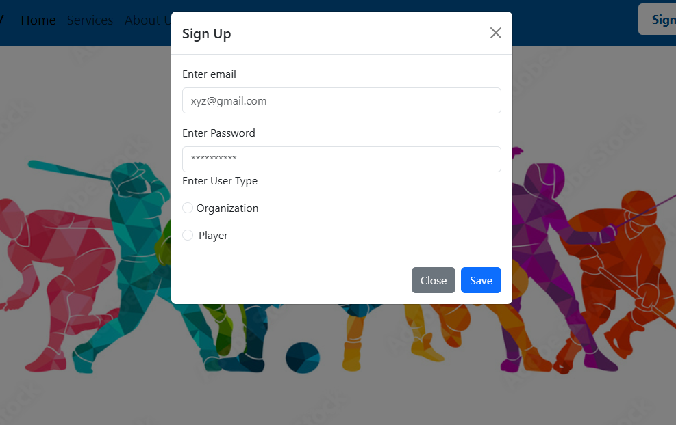

*Figure 3.4 SIGNUP MODEL*

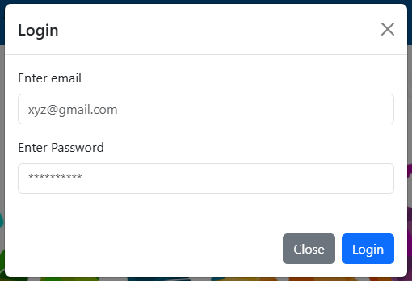

*Figure 3.5 LOGIN MODEL*

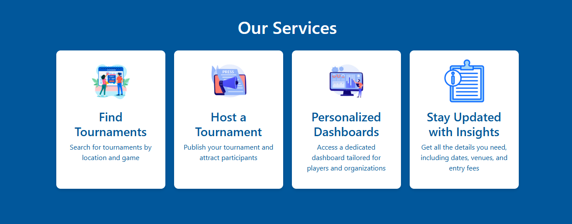

*Figure 3.6 Services Section*

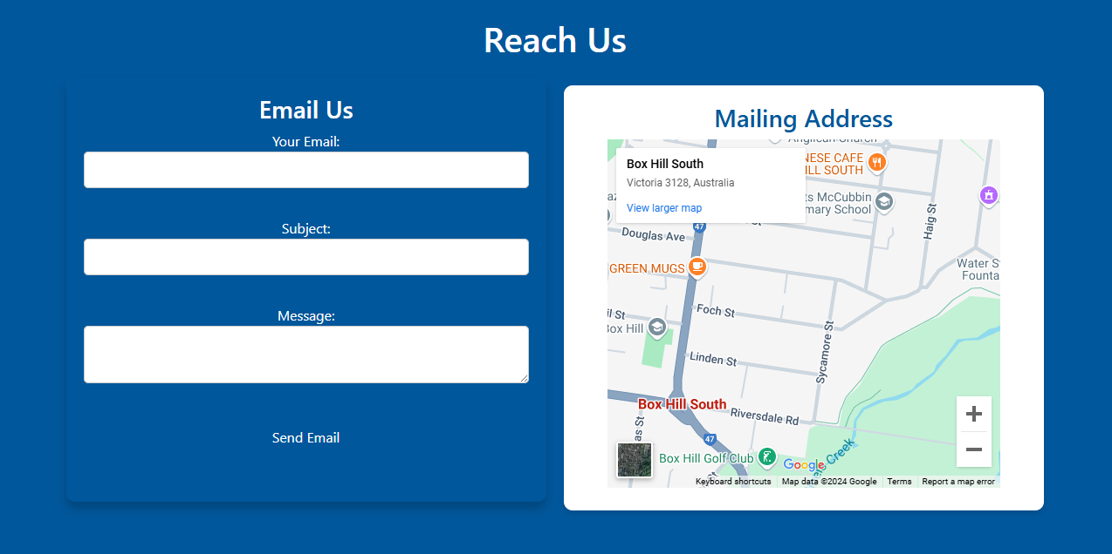

*Figure 3.7 Reach Us Section*

**3.2 ORGANIZER DASHBOARD**

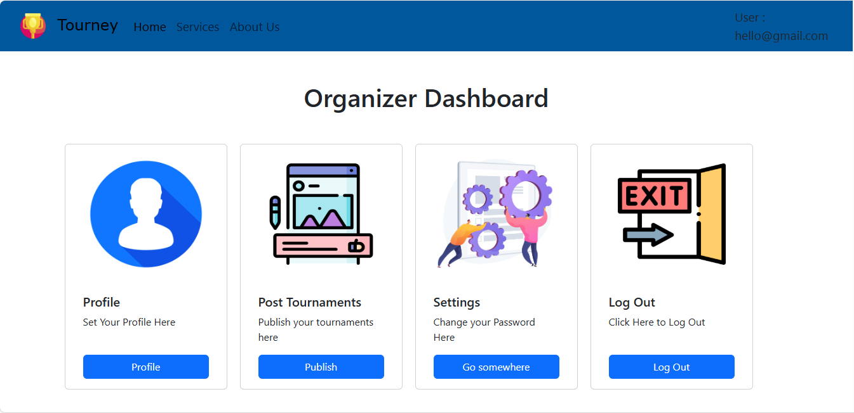

*Figure 3.8 ORGANIZER DASHBOARD*

**3.3 ORGANIZER PROFILE**

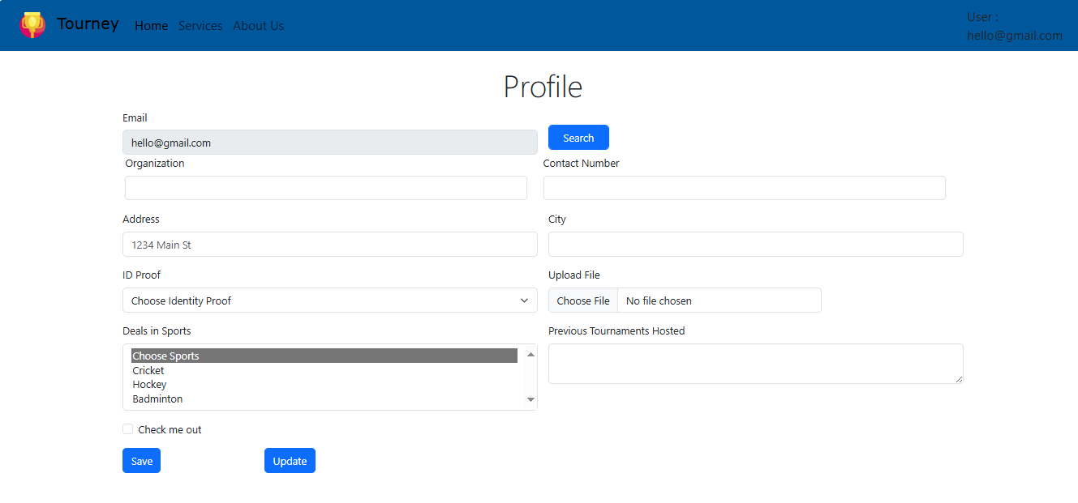

*Figure 3.9 ORGANIZER PROFILE*

**3.4 PUBLISH TOURNAMENT**

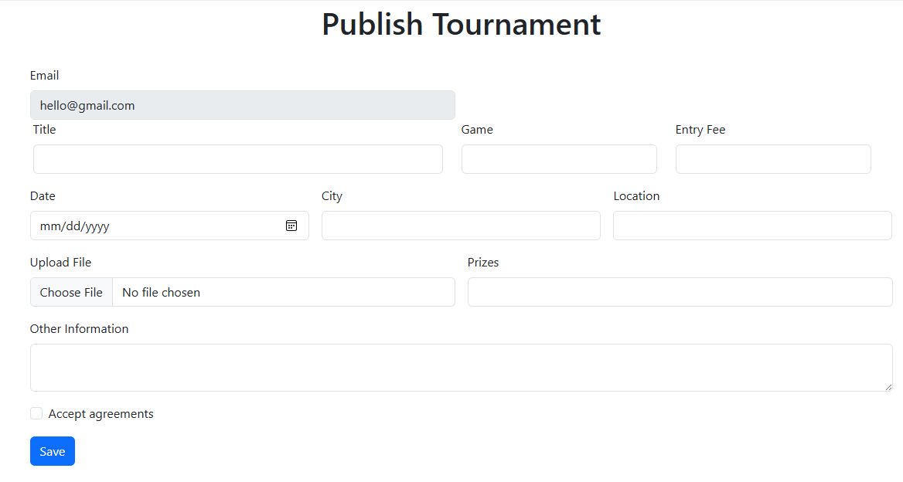

*Figure 3.10 PUBLISH TOURNAMENT*

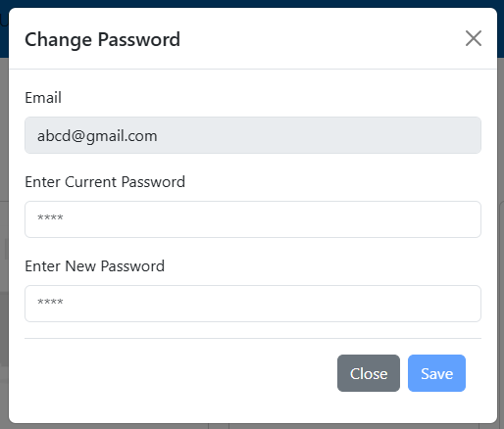

*Figure 3.11 Password Change Modal*

**3.5 PLAYER DASHBOARD**

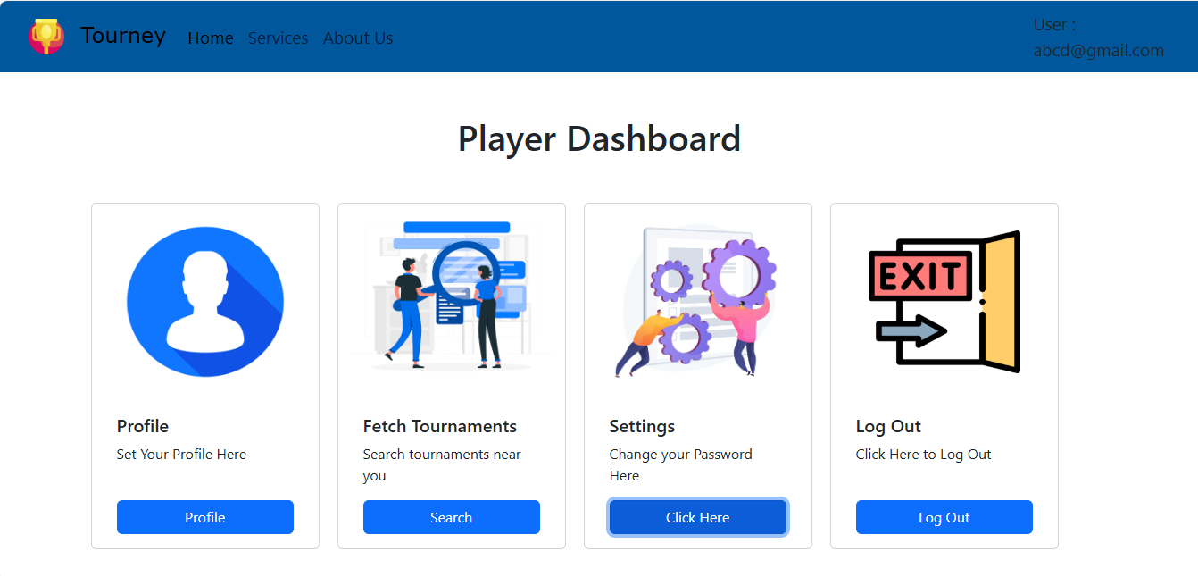

*Figure 3.12 PLAYER DASHBOARD*

**3.6 PLAYER PROFILE**

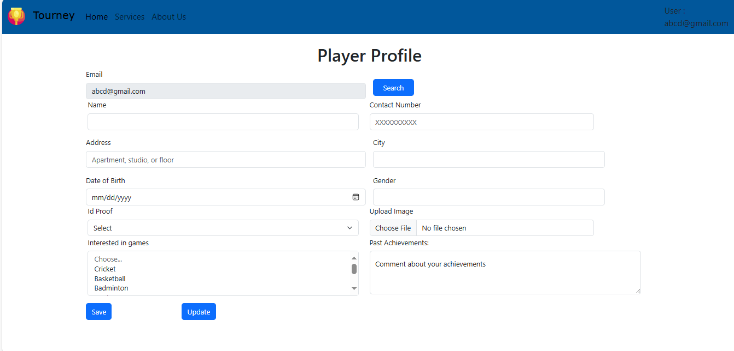

*Figure 3.13 PLAYER PROFILE*

**3.7 SEARCH TOURNAMENTS**

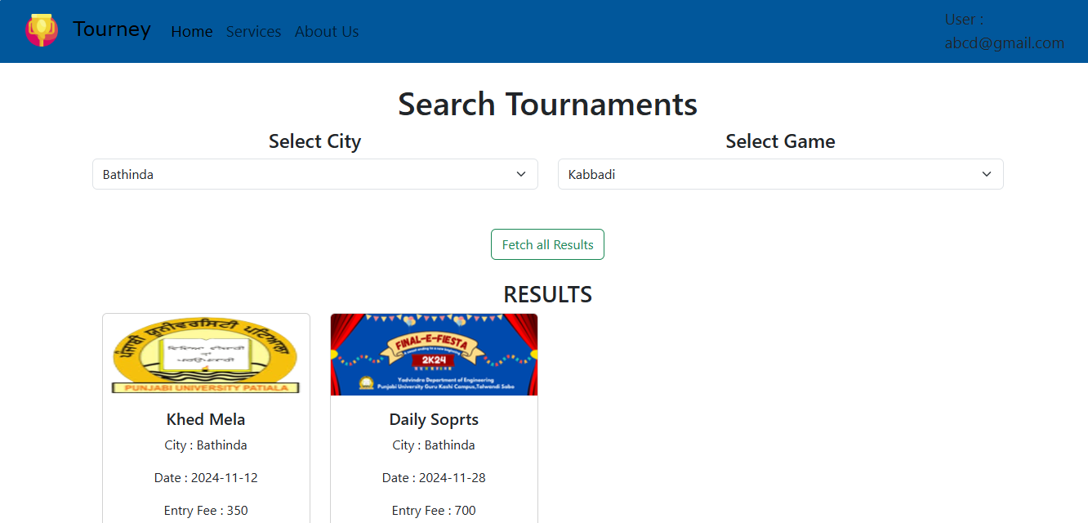

*Figure 3.14 SEARCH TOURNAMENT*

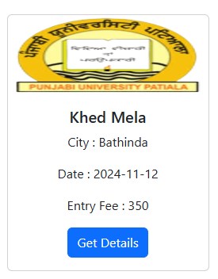

*Figure 4.5 TOURNAMENT CARD*

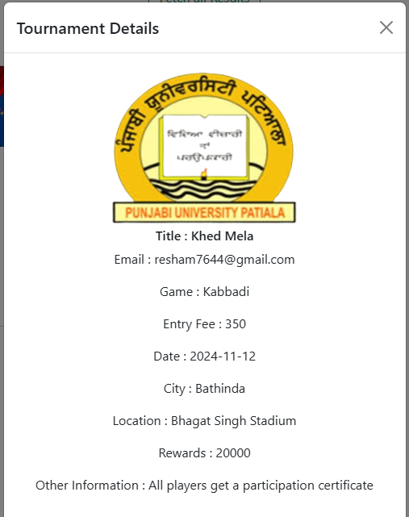

*Figure 3.15 INVESTOR PROFILE*

# 

# RESULTS

The Tourney project has successfully achieved its objectives, delivering a robust and user-friendly platform for discovering and managing tournaments:

• **Enhanced User Engagement:**

The implementation of dashboards for players and organizers, coupled with intuitive profile and tournament management features, has significantly boosted user engagement. Players can effortlessly search for tournaments based on city and game, while organizers can efficiently create, promote, and manage their events, leading to higher user satisfaction and retention.

• **Streamlined Tournament Management:**

The platform's capabilities for event scheduling, participant registration, and results tracking have simplified the management of tournaments. Organizers can set up tournaments seamlessly, track participants, and share results, while players can register with ease, ensuring efficient and transparent interactions.

• **Seamless User Experience:**

A clean and responsive user interface with intuitive navigation ensures an engaging and smooth experience for all users. Features like city and game-based filtering, personalized dashboards, and tournament tracking are designed for maximum usability, encouraging frequent use of the platform.

• **Improved Communication:**

Integrated email notifications keep users updated on tournament registrations, upcoming events, and key announcements. This ensures players and organizers stay well-informed, improving communication and fostering collaboration within the community.

# FUTURE SCOPE

The *Tourney* platform can evolve and enhance its functionality with the following future developments:

1. **Mobile Application Development**

Introduce mobile apps for iOS and Android, offering users on-the-go access to tournaments, player dashboards, and event management tools. A mobile interface will make the platform more accessible and user-friendly.

1. **Real-Time Matchmaking and Scheduling**

Implement intelligent algorithms for real-time tournament matchmaking and dynamic scheduling to accommodate last-minute changes and ensure fair competition based on skill levels or preferences.

1. **Advanced Analytics**

Integrate analytics for tracking tournament trends, player performance, and user engagement. This data can help players and organizers make informed decisions and improve their strategies.

1. **Social Media Integration**

Allow users to connect their profiles with platforms like Facebook, Instagram, and LinkedIn for sharing achievements, promoting tournaments, and gaining visibility.

1. **Virtual and Hybrid Events Support**

Enable features for hosting virtual or hybrid tournaments, including live streaming, virtual arenas, and online commentary. This will broaden accessibility and appeal to a global audience.

1. **Monetization Opportunities**

Explore monetization options such as premium memberships, sponsored events, advertising, and integrated e-commerce for gaming merchandise and tournament-related gear.

1. **Community Engagement Features**

Foster community growth with forums, discussion boards, and gamified interactions like leaderboards and rewards to encourage participation and collaboration among users.

1. **Enhanced Security Measures**

Employ robust security protocols for player data protection, secure payment systems, and fair play enforcement through anti-cheating mechanisms.

1. **Partnerships and Collaborations**

Build partnerships with game developers, sponsors, and esports organizations to provide exclusive benefits, such as in-game rewards, larger prize pools, and event promotions.

1. **Customizable Features for Organizers**

Provide tools for organizers to customize tournament formats, rules, and branding, making the platform adaptable for diverse types of games and communities.

**CONCLUSION**

The Tourney project has successfully developed a user-friendly and efficient web platform aimed at connecting players with tournaments and empowering organizers to publish their events seamlessly. By leveraging modern web technologies such as [HTML, CSS, JavaScript, and NODEJS, AngularJS, MySQL], the platform provides an intuitive experience for discovering tournaments, registering participants.

Key features of the platform include secure user registration and login, personalized dashboards for players and organizers, tournament search by city and game. These functionalities have enhanced user engagement and streamlined tournament organization, ensuring a seamless experience for all stakeholders.

Future developments, such as the introduction of mobile applications, advanced analytics for tracking tournament participation and performance, real-time communication tools, and support for online tournaments, will further expand the platform's capabilities. Integrating gamification elements, personalized dashboards, and third-party services will broaden the platform's appeal and usability.

Overall, Tourney has laid a solid foundation for creating a vibrant digital ecosystem that bridges the gap between players and tournament organizers. The project has great potential to grow into a comprehensive platform that fosters collaboration, encourages participation, and supports the growth of gaming and sports communities.